Module 7 Critical Thinking
Write a program that creates a dictionary containing course numbers and the room numbers of the rooms where the courses meet. The dictionary should have the following key-value pairs:
Key-Value Pairs: Room Number
Course Number (key) | Room Number (value)
CSC101 | 3004
CSC102 | 4501
CSC103 | 6755
NET110 | 1244
COM241 | 1411

The program should also create a dictionary containing course numbers and the names of the instructors that teach each course. The dictionary should have the following key-value pairs:
Key-Value Pairs: Instructors
Course Number (key) | Instructor (value)
CSC101 | Haynes
CSC102 | Alvarado
CSC103 | Rich
NET110 | Burke
COM241 | Lee

The program should also create a dictionary containing course numbers and the meeting times of each course. The dictionary should have the following key-value pairs:
Key-Value Pairs: Meeting Time
Course Number (key) | Meeting Time (value)
CSC101 | 8:00 a.m.
CSC102 | 9:00 a.m.
CSC103 | 10:00 a.m.
NET110 | 11:00 a.m.
COM241 | 1:00 p.m.

The program should let the user enter a course number and then it should display the course's room number, instructor, and meeting time.
Submission:
Compile and submit your pseudocode, source code, screenshots of the application executing the code, the results and GIT repository in a single document (Word is preferred).

Source Code (there are three .txt files needed for program to work and need to be located in same directory that .py scrip is running:

#need directory for where .txt files are, should be put in current directory where .py script is
from pathlib import Path

#function for opening passed in .txt then creat a dictionary and return dictionary
def open_file_with_pathlib_return_dictionary(file_name):
script_dir = Path(__file__).resolve().parent
file_path = script_dir / file_name

with open(file_path, 'r') as file:
content = file.readlines()

dictionary = {}

for line in content:
key, value = line.strip().split(';')
dictionary[key.strip()] = value.strip()

#return newly created dictionary
return dictionary

#Main Code empty dictionaries
rooms = {}
time = {}
instructors = {}

#open rooms.txt and read file create dictionary in function
rooms = open_file_with_pathlib_return_dictionary('rooms.txt')

#create dictionary with function
instructors = open_file_with_pathlib_return_dictionary('instructors.txt')

#create dictionary with function
time = open_file_with_pathlib_return_dictionary('time.txt')

control = True
#while loop for recursive output of class, time and instructor
while control is True:

#Print the list of courses
print("\nThe courses are:")
for cls in rooms:
print(cls)

#input for selection of class or e exit
selection = input('\nWhat course are you looking for? Enter e to exit ')
print('\n')

#exit while loop if e is entered
if selection == 'e':
print('Exiting, By')
control = False

#elif for if selection key is in room dictionary
elif selection in rooms:

print('Class', selection, 'meets in room: ', rooms[selection])
print('at time:', time[selection])
print('and is taught by Professor', instructors[selection])

control = True

#invalid entry
else:
print('Incorrect selection, please try again.')
control = True

Screen Shot in VSCode:
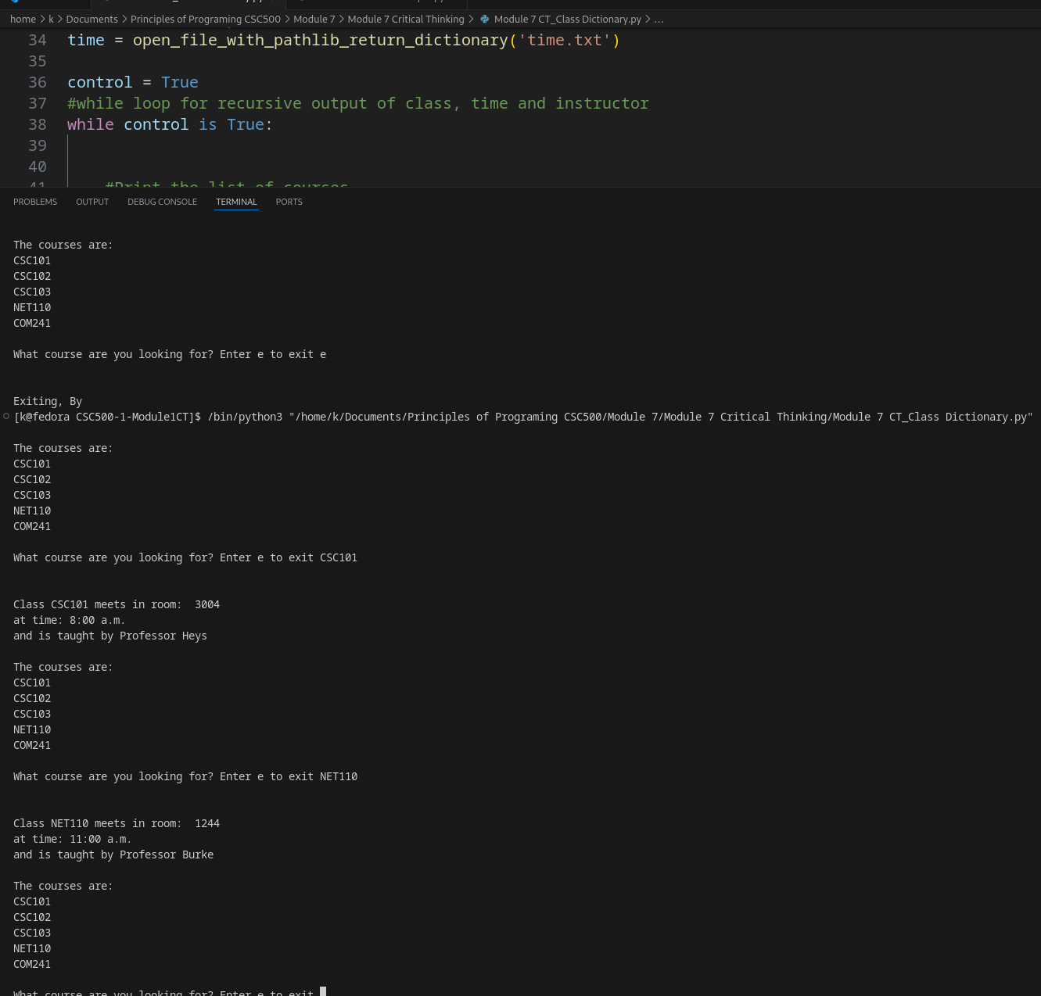

GitHub Link:
https://github.com/kcode69/Module-7-Critical-Thinking.git

